**WEEK – 2(Hands-on)**

**TDD using JUnit5**

**Exercise 1: Setting Up Junit**

<projectxmlns="http://maven.apache.org/POM/4.0.0" xmlns:xsi="http://www.w3.org/2001/XMLSchema-instance" xsi:schemaLocation="http://maven.apache.org/POM/4.0.0 https://maven.apache.org/xsd/maven-4.0.0.xsd">

<dependencies>

<dependency>

<groupId>junit</groupId>

<artifactId>junit</artifactId>

<version>4.13.2</version>

<scope>test</scope>

</dependency>

</dependencies>

<modelVersion>4.0.0</modelVersion>

<groupId>com.cognizant.week2</groupId>

<artifactId>JUnitDemo1</artifactId>

<version>0.0.1-SNAPSHOT</version>

</project>

package com.cognizant.app;

import org.junit.Test;

import static org.junit.Assert.*assertEquals*;

public class CalculatorTest {

*@Test*

public void testAdd() {

Calculator calc = new Calculator();

int result = calc.add(10, 20);

*assertEquals*(30, result);

}

}

package com.cognizant.app;

public class Calculator {

public int add(int a, int b) {

return a + b;

}

}

**Output:**

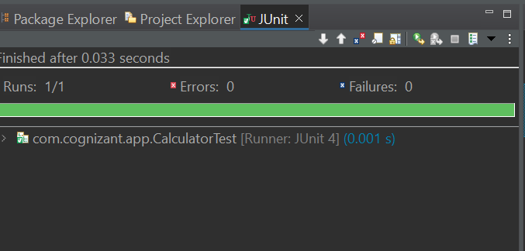

**Exercise 3: Assertions in Junit**

<projectxmlns="http://maven.apache.org/POM/4.0.0" xmlns:xsi="http://www.w3.org/2001/XMLSchema-instance" xsi:schemaLocation="http://maven.apache.org/POM/4.0.0 https://maven.apache.org/xsd/maven-4.0.0.xsd">

<dependencies>

<dependency>

<groupId>junit</groupId>

<artifactId>junit</artifactId>

<version>4.13.2</version>

<scope>test</scope>

</dependency>

</dependencies>

<modelVersion>4.0.0</modelVersion>

<groupId>com.cognizant.week2</groupId>

<artifactId>JUnitAssertions</artifactId>

<version>0.0.1-SNAPSHOT</version>

</project>

package com.cognizant.week2;

import org.junit.Test;

import static org.junit.Assert.*;

public class AssertionsTest {

*@Test*

public void testAssertions() {

*assertEquals*(5, 2 + 3);

*assertTrue*(5 > 3);

*assertFalse*(5 < 3);

*assertNull*(null);

*assertNotNull*(new Object());

}

}

**Output:**

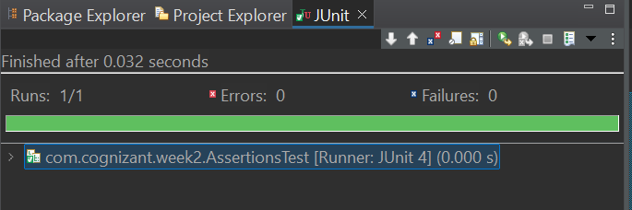

**Exercise 4: Arrange-Act-Assert (AAA) Pattern, Test Fixtures, Setup and Teardown Methods in Junit**

<projectxmlns="http://maven.apache.org/POM/4.0.0" xmlns:xsi="http://www.w3.org/2001/XMLSchema-instance" xsi:schemaLocation="http://maven.apache.org/POM/4.0.0 https://maven.apache.org/xsd/maven-4.0.0.xsd">

<dependencies>

<dependency>

<groupId>junit</groupId>

<artifactId>junit</artifactId>

<version>4.13.2</version>

<scope>test</scope>

</dependency>

</dependencies>

<modelVersion>4.0.0</modelVersion>

<groupId>com.cognizant.week2</groupId>

<artifactId>JUnitAAA</artifactId>

<version>0.0.1-SNAPSHOT</version>

</project>

package com.cognizant.week2;

public class Calculator {

public int add(int a, int b) {

return a + b;

}

public int subtract(int a, int b) {

return a - b;

}

}

package com.cognizant.week2;

import org.junit.After;

import org.junit.Before;

import org.junit.Test;

import static org.junit.Assert.*;

public class CalculatorTest {

private Calculator calculator;

*@Before*

public void setUp() {

System.***out***.println("Setting up...");

calculator = new Calculator();

}

*@Test*

public void testAdd() {

int result = calculator.add(10, 5);

*assertEquals*(15, result);

}

*@Test*

public void testSubtract() {

int result = calculator.subtract(10, 5);

*assertEquals*(5, result);

}

*@After*

public void tearDown() {

System.***out***.println("Cleaning up...");

calculator = null;

}

}

**Output:**

